# Step by step:

1. Enter API key in code

To successfully run the code you need to enter an API key in line 18 in the HomeScreen.js file. (Location: -\Group-Design-Project\app\src\views\HomeScreen.js). The key has been sent to [goetz.botterweck@tcd.ie](mailto:goetz.botterweck@tcd.ie) with the subject line “GROUP 7 API KEY”

## Have an android emulator or have an android phone

### Create an Emulator

1. Install Android studio
2. On start page click More Actions (shown in red below)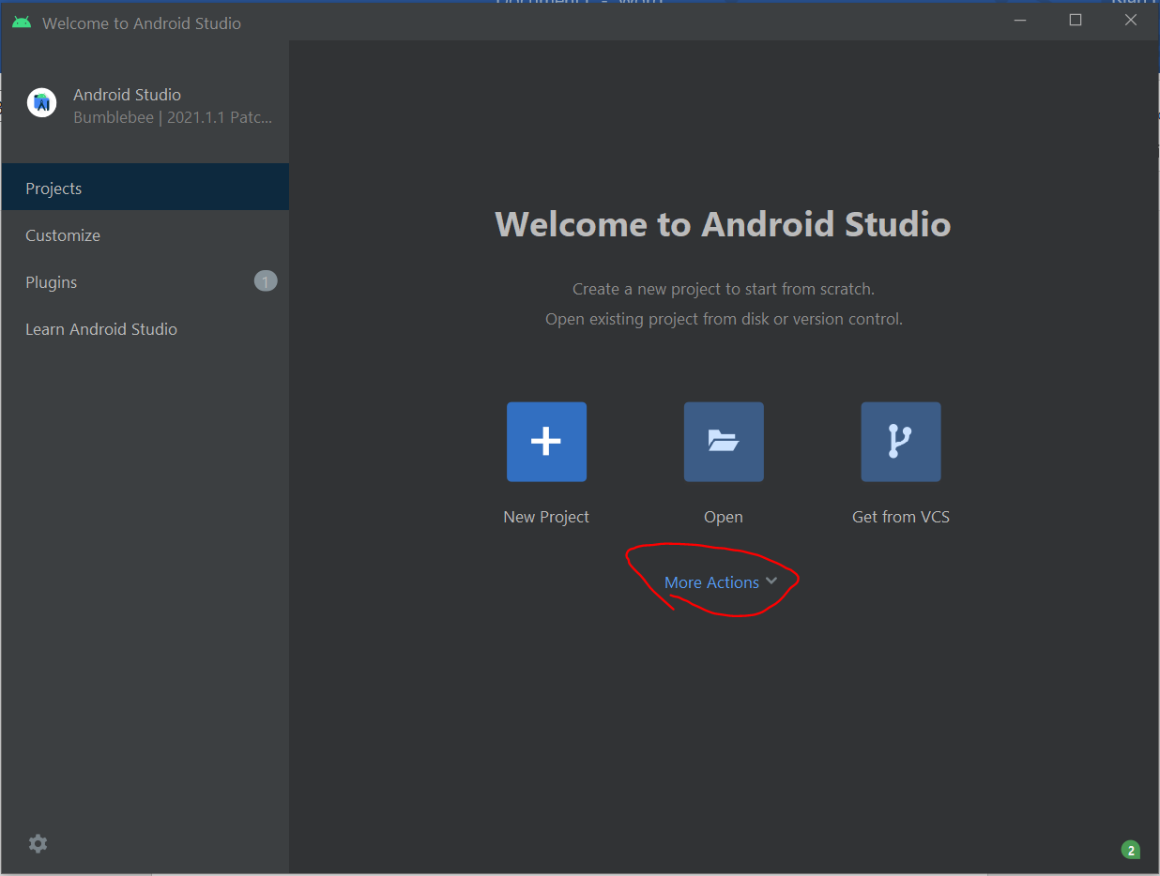
3. Click Virtual Device Manager
4. Create a device with play store capabilities (necessary icon shown in red below)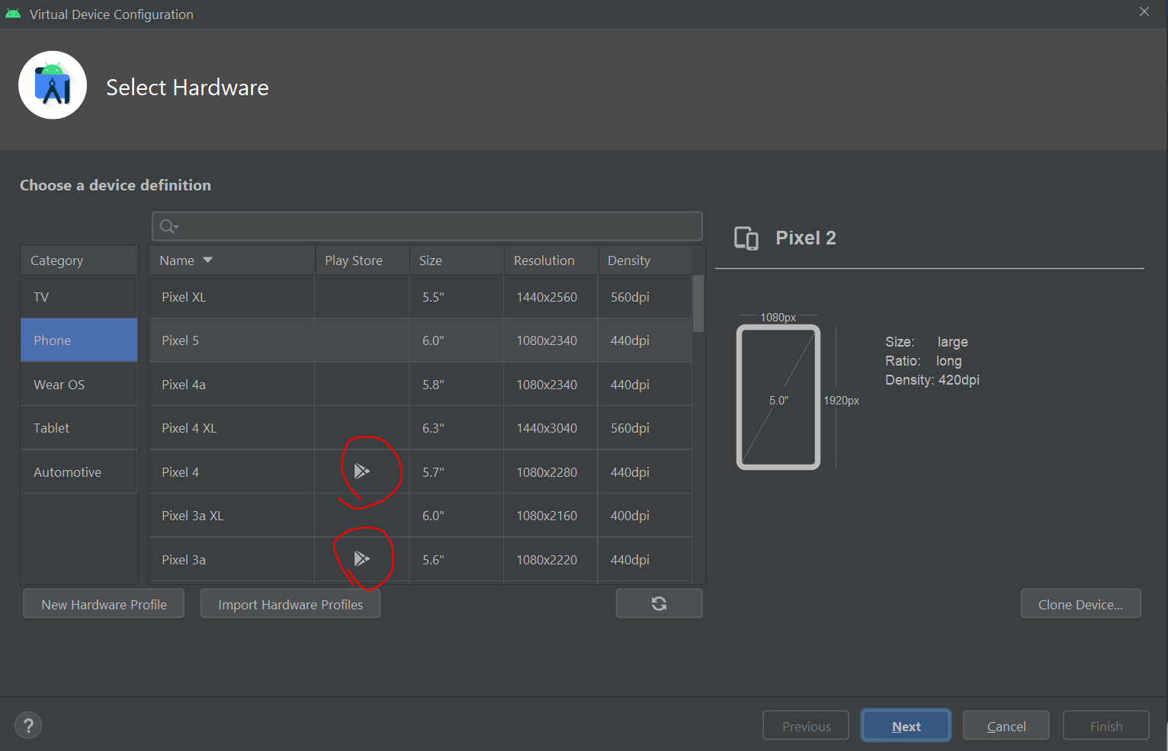
5. Open the virtual device

### With an android phone

1. Install Expo app from the Play Store

## Run the expo server

### Commands

1. npm install
2. npm install -g expo-cli
3. expo start

## Open the app in the device

1. If it’s to run on an android emulator, just press the ‘a’ key while in the expo command line interface
2. If it’s to run on an android phone, read the QR code with your phone’s camera, and the app will open using Expo

# Use Flow

1. Open app (using set-up steps outlined above)
2. Allow location access
3. If first use, create account by clicking “Register”
4. If returning user, log in by entering details & clicking the log in button
5. Once logged in, user is presented with map view
6. User is also presented with a shading of the roads which the user has already walked.
7. This dynamically updates as they walk
8. User can also visit a selection of local landmarks. The graphic marker on the map changes colour if it is visited.
9. User has a score tied to their profile that takes into account the distance they’ve walked along roads in their area.